# 

Effect of Public Debt on Equity Prices

Marvin Henry

# 

# 

# 

# 

# 

# 

# 

# 

# Introduction

At the beginning of January 2023, the United States national debt broke a record $31 trillion dollars which is a tremendous amount however in a few months or even weeks the country’s debt levels will round the corner at $34 trillion dollars. With the nation still recovering from the 2008 recession, economic shocks of the pandemic and multiple global conflicts that have occurred over the course of this year the country’s debt has increased by about 2 trillion dollars. The International Monetary Fund notes that the US is not the only country with a national debt problem as the world’s public debt levels have tripled since the 1970s reaching about 92% of global gross domestic product and private debt since the 1960s has tripled to nearly 147% of GDP (Gasper et al, 2023). So, with world governments having spending habits equivalent to “a spendthrift teenager with their first credit card” (Financial Times, 2023), one must think to what extent our institutions’ spending habits have on other economic forces, functions and markets?

To answer the question, first one must consider the obligations being accounted for in the national debt. According to the Treasury, the US national debt is the amount of money the government had to borrow to cover any outstanding expenses incurred over time. Therefore, when the spending within the fiscal year exceeds the available tax revenues the Treasury would need to borrow in order to pay off those obligations. One method the Treasury uses to borrow money is through the auctioning of government securities called Treasuries. US Treasuries are financial instruments with a set interest rate that fluctuates due to changes of the federal funds rate target and due to other securities being simultaneously offered in the market. Treasuries can have varying maturities and fit into three broad groups: bills that represent maturities that start at 4 weeks to 52 weeks, notes represent the maturities that start at 2 years to 10 years and finally bonds that have maturities of 20 years or 30 years.

With the assistance of sales of these marketable securities the Treasury is able to gain quick liquidity to handle some of their obligations and the Treasury can also sell nonmarketable securities like savings bonds instead. However, selling government securities comes with an increase to the public debt, since the Treasuries sold have an interest rate attached to it and that becomes an obligation to pay off later. Thus raising the public debt limit would allow the Treasury to increase the supply of Treasuries and would theoretically be negative from the standpoint of public debt management since the increase of interest payments would correlate with an increase in the public debt. This is what prompts this study on national debt and how it affects other variables in the economy especially since marketable government securities play a role in our present financial markets. Furthermore, as of October the Treasury would also have to spend $89 billion to maintain US debt which is about 19% of the total federal spending (Fiscal Data explains the National Debt, 2023), which raises more questions about public debt management and whether selling government securities can be considered a reasonable long-term solution to quell obligations.

# Literature Review

Considering the multiple economic forces that can be established as links for which the public debt can affect our financial markets, this study will focus on the effects of rational expectations. Rational expectations theory illustrates the idea that expectations are affected by the amount of public information that is available for use and that would affect how the market prices certain goods and services as theorized by Muth (1961). Information is a scarce resource that is not wasted by the economy, information can be the effect of some exogenous variable like the news, and it can then be inferred that exogenous shocks can affect prices in unforeseen ways. News concerning consumer price index and unemployment has been shown to influence stock prices in a contemporaneous manner and the effect was not substantial (Jain, 1988). Comparably, it has been documented that surprise changes in inflation would have some marginal effect on equity prices, indicating that unanticipated information would have a large effect on equities (Schwert, 1981). In short, information affects the expectations about different products by either increasing or decreasing the possible outcomes theorized by market participants; in other words, possible outcomes are conditional on the public set of information and expectations are conditional on the outcomes generated from the information accumulated. Through the application of rational expectations, the results will supplement this literature by exploring the theoretical effect of information and rational expectations caused by the aggregate national debt.

Another aspect that would have to be considered when formulating rational expectations concerns the structure of the economic systems that could influence the behavior of the participants. The researcher can then infer that information about the structures that occupy the economy would also produce some expectations, since pricing models attempt to capture the expectations using the information that is currently available that would arbitrarily limit the scope of the possible outcomes theorized based on the set of public information (Muth, 1961). So, effects of monetary policy and fiscal policy should also be considered when formulating the possible outcomes concerning a specific security. There is literature that documents effects of unanticipated monetary policy on equity prices, showing that there are substantial effects on equity prices when the target rate for monetary policy has not been modeled for (Bernanke and Kuttner, 2005). Indicating that monetary policy can have a substantial effect on stock prices in the short term, and adjusting the federal funds rate target has been shown to be effective in stimulating economic development as well. So, when considering the effects of public debt on equity prices, it becomes imperative to model that intertemporal relationship between securities and monetary policy to better comprehend its behavior. Additionally, the study of these macroeconomic variables would prompt the investigation of these behaviors and the investigation will help comprehend this link.

Fiscal policy can also contribute to the shift of expectations as that would entail the debt management policies that are determined by Congress. By way of increasing the debt limit that would enable the Treasury to sell more securities, and that would theoretically shift the expectations of those participating in both the bond and equity markets as they would anticipate an inflow of US government securities into the financial system. Congress could also suspend the debt limit and allow for more borrowing, following a period of time there would be an adjustment to the debt limit to compensate for the spending in that period. Then the increase of the supply of Treasuries would affect the value of Treasuries themselves and since there are goods that are substitutable in the market those securities would be affected as well (Roley, 1982). With changes in the supply of US Treasuries, the term structure of the existing and future securities could influence a shift in investor sentiment towards certain goods and services that are substitutes or complements of US Treasuries.

There exists literature that documents the changes in the supply of some financial instrument leads to that item becoming more valuable. As seen by Krishnamurthy and Vissing-Jorgensen (2012) with their findings revolving around the characteristics of US treasuries where they document changes in Treasury supply affecting different yield spreads. Treasuries are highly liquidity instruments, and it has been found to be comparable to the medium of money and its own supply affects its value. Specifically, the conclusion that was reached is that when the supply of Treasuries is low those securities are valued higher and the phenomenon is reversed when the supply of Treasuries are high (Krishnamurthy et al, 2012). The attributes of safety and high liquidity leads investors to have higher valuations of Treasuries creating this unique demand for riskless assets making those assets more valuable. It has also been seen that expanding the stock of riskless assets reduces risk premia and raises riskless rates (Gomes and Michaelides, 2008) and

* Krishnamurthy(2002) notes changes in the liquidity premia for both long term and short term treasuries

Conclusions

* One standard deviation in average treasury supply lowers Treasury yields by about 77 basis points relative to Baa-rated corporate bonds
  + And for long term treasuries a one-standard-deviation decrease in the supply of long term treasuries would rise the price of long-term safety by about 40 basis points
  + An increase to Treasury supply in terms of the amount public held debt shown to affect the yields spreads of Baa-Aaa negatively, so an increase in public held debt would affect the demand of Baa-rated bonds negatively

That shift in investor sentiment could induce the investor to make certain decisions, investor sentiment constitutes beliefs about cash flows and investment risks that are not justified by the facts at hand (Baker and Wurgler, 2007). This would complicate the effect of rational expectations on specific securities as their values could be affected by the fluctuation of investor sentiment. Baker and Wurgler found sentiment to affect stock prices that are harder to value or arbitrage, these are securities that are highly volatile and have underlying institutions that have the potential to be profitable. Comparably more stable companies that have returns alike to returns that are bond-like would not be affected by the shifts of sentiment, that is the result of more experience.

# Data

The data is a time series that observes multiple variables over time across 20 years from January 1, 2001 to December 31, 2019. The target variable is the values of public debt and instead of using daily public debt data, I cleaned the data for the debt values on Friday which would be the end of the week, transformed the data from dollars to millions by dividing by the levels by one million which was done to eliminate the scientific notation, and then adjusted the nominal value to real dollars using the 2015 consumer price index not including food and energy. The main dependent variable was the weekly averages of the Russell 2000 Index, which contains 2000 companies offered on the secondary market that meet the market capitalization requirements established by . The dependent variable helps to proxy the effect of public debt on small-cap companies and presenting the data in weekly averages allows the contemporaneous effects to better evaluated. Then to model the effects of other markets relative to the index values, weekly average interest rates for US 10-year Treasury note and the Moody’s Baa Corporate Bond Index are considered as well. 10-year Treasury yields help to proxy for the general effect of US Treasuries can have on the stock values of small-cap companies.

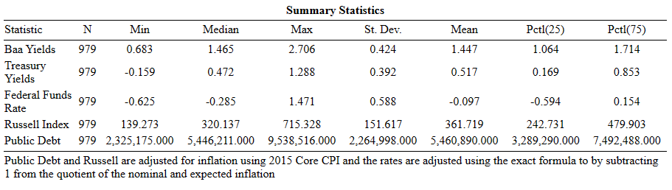

# Methodology

Prior to the Vector Autoregression (VAR) and Structural VAR(SVAR) the relationships between macroeconomic forces were analyzed using large scale structural simultaneous models. It was found that these models were not capable of forecasting the numerous unprecedented events, which was considered a big failure that affected many of the macro-econometric models. Sims then suggested the VAR model as a replacement for large scale macroeconomic studies over time in his paper *Macroeconomics and Reality* in 1980, touting that the VAR had greater success then the simultaneous equations systems but had an issue with instantaneous correlations in the error terms and observable variables. Then the SVAR allowed for those correlations to be disentangled by placing restrictions on the VAR equations (Amisano and Giannini, 1997). Before discussing the SVAR, the VAR is a multivariate modeling method that allows for a vector of at least two time series variables, this methodology allows for a certain number of lags that can be determined using an information criterion function (Stock and Watson, 2011).

VARs assume the variables being modeled are stationary values that either are integrated to some unit root *d* or have passed some formal test of stationary like the Augmented-Dickey-Fuller Test. Before modeling the equations, the researcher tested and made sure that all the variables were stationary or transformed the data to first differences for the variable(s) in question. The study modeled the endogenous variables using non-stationary data as well to demonstrate the differences in the computed causality of the VAR models. The coefficients were estimated using the Ordinary Least Squares method (OLS) and the best model was determined by calculating the maximum log likelihood of getting the dependent variable. When modeling VAR models the analyst would have to consider whether the variables being modeled can be considered to have endogeneity or exogeneity. A test that can uncover the endogeneity of a variable and prove its significance to the study at hand is the Granger causality test. Granger causality tests allow the researcher to determine whether the regressors have some predictive content for the variable (Stock and Watson, 2011) this case uses the causality test to determine if 10-year Note yields and Baa corporate bond yields has some predictive elements for the Russell 2000.

Making use of a VAR (2), the first and second lags of each variable are considered and the VAR model being used is a reduced-form VAR that illustrates each variable as a linear function of its lags and the lags of other variables and assumes its error term is serially uncorrelated (Stock and Watson, 2001):

1. Treasuryt = 10 + 11Treasuryt-1 + 12Treasuryt-2 + 11Baat-1 + 12Baat-2 + 11Russellt-1 + 12Russellt-2 + 1t
2. Baat = 20 + 21Treasuryt-1 + 22Treasuryt-2 + 21Baat-1 + 22Baat-2 + 21Russellt-1 + 22Russellt-2 + 2t
3. Russellt = 30 + 31Treasuryt-1 + 32Treasuryt-2 + 31Baat-1 + 32Baat-2 + 31Russellt-1 + 32Russellt-2 + 3t

These equations allow the researcher to explore whether the endogeneity between these variables above, then utilizing the Granger test to search for causality in each linear function it was determined how the variables would be ordered in the SVAR and structuring of the matrices.

Constructing these models involves picking out variables that make use of economic theory and explains relations between the variables of interest, when it comes to this study utilizing well developed theory and accumulated research determined the models for these variables. In particular, when picking out variables to model that change in rational expectations it becomes important that the econometrician researches a well-suited proxy to show the shift in rational expectations.

A SVAR model is employed allowing the researcher to structure restrictions using matrices, these matrices help to model contemporaneous relationships between different macro variables. To effectively model the intertemporal relationships the AB model as illustrated by Lütkepohl(2005) allows one to consider the restrictions of both the A matrix and B matrix simultaneously. A-matrix denotes the instantaneous relationship between the observable variables, allows for a lower triangle structuring that can depict a causal ordering where *y1t* would have an instantaneous impact on all the other variables, and then *y2t* would have an instantaneous impact on the other variables excluding *y1t* and then so on. B-matrix denotes the unexpected shock that comes from the relations between the observable variables and would be structured as diagonal values that can be used to determine the effect of a positive shock to a particular variable The AB model combines the restrictions of the A matrix and B-matrix to consider the simultaneous equations systems that considers:

$A=\left[\begin{matrix}1 & 0 & 0 & 0 \\ a_{21} & 1 & 0 & 0 \\ a_{31} & a_{32} & 1 & 0 \\ a_{41} & a_{42} & a_{43} & 1\end{matrix}\right]$ $B=\left[\begin{matrix}b_{11} & 0 & 0 & 0 \\ 0 & b_{22} & 0 & 0 \\ 0 & 0 & b_{33} & 0 \\ 0 & 0 & 0 & b_{44}\end{matrix}\right]$

A*ut=* B*𝜀t*

which formulates for errors of the reduced form models rather than the observable variables, therefore accounting for the shift from specified direct relations for observable variables to formulating relations for the shocks themselves (Amisano and Giannini, 1997). Through these matrices one can consider the errors of the variables themselves and then we consider the structural shocks that would affect that variable as well.

. Blanchard and had a study in 1989 that utilizes a SVAR using the AB matrix to model the macroeconomic fluctuations that affect a vector of variables. The results allow for several inferences to be made about the graph and help to better comprehend those relationships.

Blanchard

# Results

In Fig. 1 we notice that there is a difference in causality between the results of the Granger causality tests. Tables (a) and (c) show the results of the causality tests using the models in the previous section. The determines the causality of the variables that are non-stationary, or level data and it shows that both yields in the 10-year note and corporate bond can cause some of the variation in the data. With the probability of Chi2 being below 0.01, it can be interpreted at the 1% significance level that both variables and their two lags have some predictive content for the Russell 2000 index at time *T*:

Figure 1.

(a) (b)

(d)

(c)

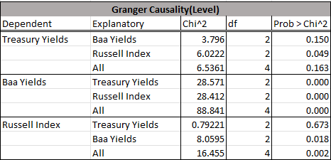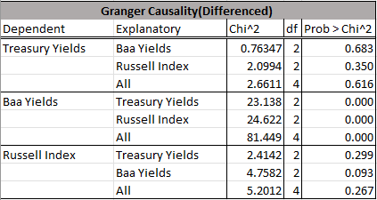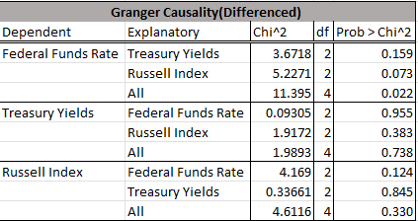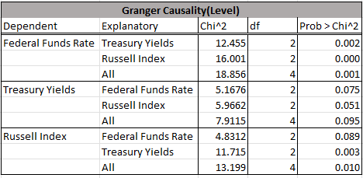

Tables (a) and (b) tests Granger causality on the models introduced in the methodology section earlier, (a) uses data that was left undifferenced comparably (b) uses data that was differenced. The data was differenced only once as the data was defined as stationary after being differenced once. Tables (c) and (d) tests Granger causality on models that relates the changes in the federal funds rate(FFR):

1. y(Federal Funds Rate, Treasury Yields, Russell Index)t  = 10 + 11FFRt-1 + 12FFRt-2 + 11Treasuryt-1 + 12Treauryt-2 + 11Russellt-1 + 12Russellt-2 + 1t

This makes sense considering that investors would consider the substitutability between the bond market and the equity markets. When the available information concerning either market affects future expectations that could lead to the investor switching to another market in an attempt to arbitrage. That behavior from the investor would also be a shift in investor sentiment as information about future cash flows can influence the decisions of the risk averse investor(Baker and Wurgler, 2007). Additionally, with small market-capitalized companies

Table (b) and (d) are the Granger causality tests that assessed the VARs that had differenced values or stationary values and contrasted heavily with the causality discovered in the first table. It can be interpreted from the probability of Chi2 in (b) that corporate bond yields have same causality that is significant at the 10% level for the Russell 2000 but there was no causality on any level of significance for the 10-year note on the Russell 2000. Interestingly, both tables (a) and (b) depicts the 10-year note and the Russell 2000 index have some causality for Baa corporate bond yields that is significance to the 1% level. That can be an indication that the performance of both small market-cap companies and US Treasuries can affect the yields of Baa corporate bond yields. That would make sense as stocks are riskier investments that have more volatility compared to fixed-income assets like corporate bonds and Treasuries. So, if an investor wants to diversify their portfolio with products related to private companies but does not want to expose themselves to the risks of stocks then corporate bonds would be a proper substitute. Therefore, the demand for stocks can be affected by the less risky market in corporate bonds that can offer more stable returns for lower risk compared to equities. In table (b) that idea is alluded to with the Baa yields having causality at the 10% level for the Russell Index, indicating that corporate bonds has some

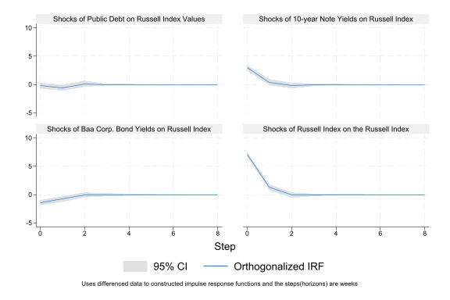

Citations

Amisano, G., & Giannini, C. (1997). From VAR models to Structural VAR. In *Topics in structural VAR econometrics* (pp. 1–26). Springer-Verlag.

Baker, M., & Wurgler, J. (2007). Investor Sentiment in the Stock Market. *The Journal of Economic Perspectives*, *21*(2), 129–151. <http://www.jstor.org/stable/30033721>

Blanchard, O. J., & Quah, D. (1989). The Dynamic Effects of Aggregate Demand and Supply Disturbances. *The American Economic Review*, *79*(4), 655–673. <http://www.jstor.org/stable/1827924>

*Federal debt and the statutory limit*. Congressional Budget Office. (2023, May). <https://www.cbo.gov/publication/59160>

*Fiscal Data explains the National Debt*. Understanding the National Debt | U.S. Treasury Fiscal Data.(2023). <https://fiscaldata.treasury.gov/americas-finance-guide/national-debt/>

Gaspar, V., Poplawski-Ribeiro, M., & Yoo, J. (2023, September 13). Global Debt is Returning to its Rising Trends. *International Monetary Fund*. <https://www.imf.org/en/Blogs/Articles/2023/09/13/global-debt-is-returning-to-its-rising-trend#:~:text=Forces%20in%20debt%20trends&text=Global%20public%20debt%20tripled%20since,span%20between%201960%20and%202022>.

Lütkepohl, H. (2005). Structural VARS and VECMs. In *New introduction to multiple time series analysis* (pp. 358–367). Springer-Verlag.

Muth, J. F. (1961). Rational Expectations and the Theory of Price Movements. *Econometrica*, *29*(3), 315–335. <https://doi.org/10.2307/1909635>

Reinhart, V., Sack, B., & Heaton, J. (2000). The Economic Consequences of Disappearing Government Debt. *Brookings Papers on Economic Activity*, *2000*(2), 163–220. <http://www.jstor.org/stable/2667358>

Roley, V. V. (1982). The Effect of Federal Debt-Management Policy on Corporate Bond and Equity Yields. *The Quarterly Journal of Economics*, *97*(4), 645–668. <https://doi.org/10.2307/1885104>

Stock, J. H., & Watson, M. W. (2001). Vector Autoregressions. *The Journal of Economic Perspectives*, *15*(4), 101–115. <http://www.jstor.org/stable/2696519>

Stock, J. H., & Watson, M. W. (2011). Introduction to Time Series Regression and Forecasting. In *Introduction to econometrics* (3rd ed., pp. 516–569). essay, Addison-Wesley.

*The world’s public debt problem*. Financial Times. (2023, June 2). <https://www.ft.com/content/c8f5ba07-1d74-4dce-a9b6-983e4e5380e1>